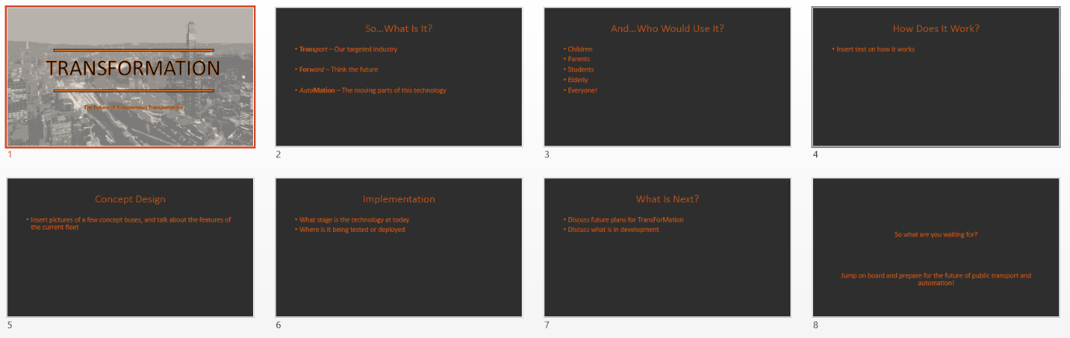**TransForMation Story Board**

**Slide 1:** Displays the group name and the slogan

**Slide 2:** Describes the meaning of the name, whilst presenting this slide we’ll be explaining each concept and how it relates to the project

**Slide 3:** This slide will break down the best use cases and what they’re the target audience. At the end of the day the final point of the slide will reveal that this technology is for all to use and does not target a specific demographic

**Slide 4:** Maybe this slide will be super technical, but it’s likely that I’ll address the key workings of the bus and the automation behind it as it has a greater selling point if it is easier to understand

**Slide 5:** Discuss various concept designs of existing buses and discuss modifications that we will be making to our design that will better suit the need of the users

**Slide 6:** This slide is to showcase where the technology is at (developmentally and conceptually) and how it is deployed or will be deployed in the future

**Slide 7:** Will be used to plan out the project and assess what technologies will be used and developed along the way

**Slide 8:** Closing comments and another slogan